EXPT NO:3 | CLEANSE DATA BY HANDLING MISSING VALUES, OUTLIERS, AND INCONSISTENCIES USING TABLEAU AND POWERBI
DATE: 10.07.2026

PRE-LAB QUESTIONS (PROVIDE BRIEF ANSWERS TO THE FOLLOWING QUESTIONS)

1. What are the potential impacts of missing values in a dataset, and what are some common strategies to address them in Tableau and Power BI?

Answer:
Missing values can reduce data accuracy, affect calculations, and lead to incorrect analysis results. In Tableau and Power BI, missing data can be handled by filtering null values, replacing them with appropriate values, or using calculated fields to manage incomplete records.

2. What is the importance of identifying and addressing outliers in a dataset? How can outliers affect data analysis and model performance?

Answer:
Identifying outliers is important because extreme values can distort trends, averages, and statistical analysis. In Tableau and Power BI, visualizations such as scatter plots and box plots help detect unusual values that may affect decision-making and model accuracy.

3. What types of data inconsistencies might you encounter during data cleansing, and how can Tableau and Power BI help in resolving them?

Answer:
Common inconsistencies include incorrect data types, duplicate records, inconsistent naming formats, and missing categories. Tableau and Power BI help resolve these issues through data preparation tools, filters, transformations, and calculated fields.

4. How do you identify patterns in data using visualizations to spot missing values, outliers, and inconsistencies?

Answer:
Visualizations such as scatter plots, heatmaps, line charts, and tables help identify unusual patterns, gaps, and extreme values in datasets. These charts make it easier to detect missing information, abnormal trends, and inconsistent records.

5. What is the role of calculated fields in data cleansing, and how can they be used to handle missing values and outliers in Tableau/Power BI?

Answer:
Calculated fields help create new values, correct errors, and apply custom logic during data cleaning. In Tableau and Power BI, they can be used to replace missing values, calculate error measures, classify outliers, and improve the quality of analysis.

IN-LAB EXERCISE:
OBJECTIVE:
To clean a given dataset (e.g., Superstore Sample in Tableau and Financials/Sales Data in Power BI) by identifying and resolving missing values, outliers, and inconsistencies using built-in tools, ensuring the dataset is accurate and ready for analysis.
PROCEDURE:
  - Open the Tool and Connect Dataset o Open Tableau Desktop , Power BI Desktop.
    - Load the built-in dataset (Sample - Superstore in Tableau / Financials in Power BI).
    - Preview the dataset to understand its structure.
  - Initial Inspection o Explore fields such as Sales, Profit, Region, or Product Category.
    - Check for nulls, inconsistent text values (e.g., "South Region" vs. "South"), or date formatting issues.
  - Handling Missing Values o Use Data Interpreter (Tableau) / Power Query (Power BI) to highlight nulls. o Replace missing numerical values with mean/median, and text with "Unknown".
    - Use calculated fields: IFNULL([Field], Default) in Tableau or IF(ISBLANK([Field]), "Unknown", [Field]) in Power BI.
  - Detecting and Managing Outliers o Create scatter or box plots for Sales and Profit to identify extreme values.
    - Choose strategies:
      - Filter them temporarily.
      - Apply caps using calculated columns.
      - Flag them with labels for review.
  - Resolving Inconsistencies o Use Group/Alias (Tableau) / Replace Values (Power BI) to standardize text.
    - Normalize data formats, such as date fields or currency units.
- Validation with Visuals
    - Build dashboards with histograms, bar charts, and box plots to visually confirm improvements.
    - Compare before/after cleaning stages for accuracy.
- Save the Cleaned Dataset o Save as .twbx (Tableau) / .pbix (Power BI).
o Optionally export cleaned data to .csv.
- Summary Dashboard
o Create a visual summary of the cleaning process, highlighting:
      - Fields corrected.
      - Nulls/outliers removed or adjusted.
      - Clean dataset metrics (record count, completeness %).

Experiment Dataset:
  - Tableau: Sample - Superstore
  - Power BI: Financials or Sales Data
How to Access:
Tableau:
  - Navigate to: Start Page → Sample Workbooks
  - Or: Help → Sample Data → Open Sample Data Folder
Power BI:
  - Navigate to: Home → Get Data → Excel → Choose sample datasets (e.g., Financial Sample.xlsx)
  - Microsoft also hosts Power BI sample datasets online.
Fields Used:
  - Sales
  - Profit
  - Region
  - Category
  - Order Date / Transaction Date

Tableau:
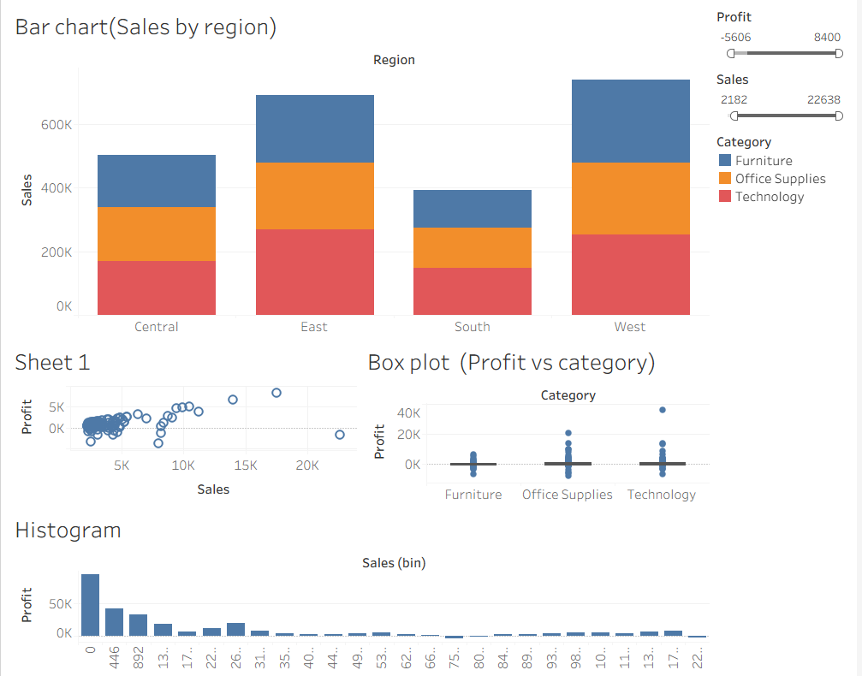

Power BI:
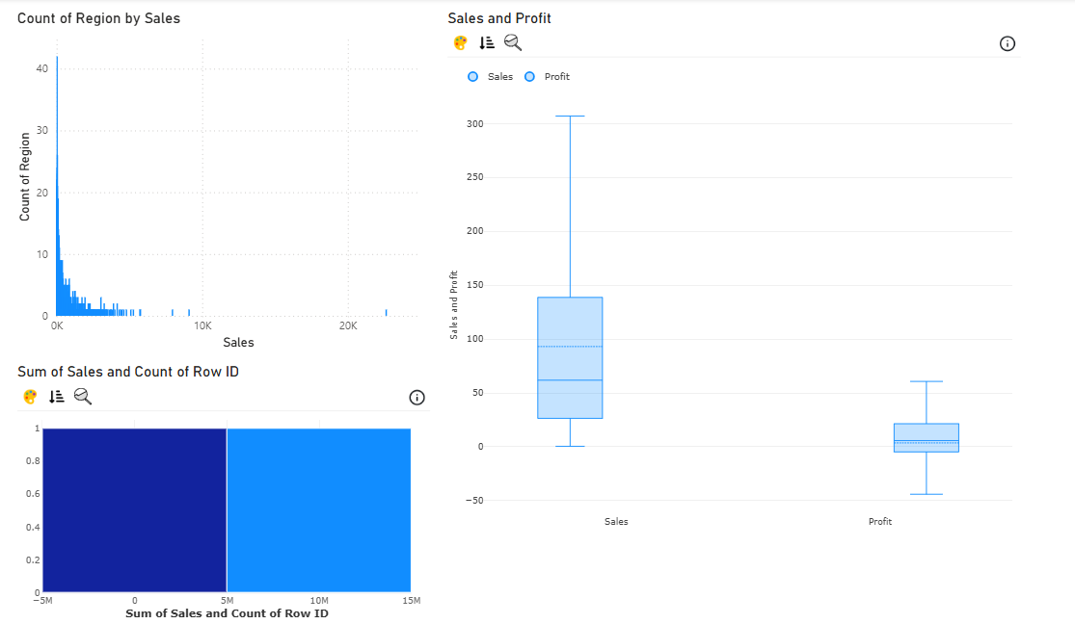
POST-LAB QUESTIONS (PROVIDE BRIEF ANSWERS TO THE FOLLOWING QUESTIONS)
1. What method did you use to replace missing values in numeric fields?

Answer:
Missing numeric values were handled by replacing them with a default value such as 0 or using statistical values like the mean/median when appropriate. In Tableau, calculated fields using IFNULL() were used, while Power BI used Power Query transformations to replace null values.

2. How were outliers handled in your dataset and what visual confirmed their correction?

Answer:
Outliers were identified using scatter plots and box plots by checking unusual Sales and Profit values. They were handled by filtering extreme values, creating outlier flags, or applying limits, and the corrected data was verified using updated visualizations.

3. What inconsistencies were detected in categorical values and how were they standardized?

Answer:
Inconsistent categorical values such as different names for the same region or category were identified during data inspection. They were standardized using Aliases/Groups in Tableau and Replace Values in Power BI Power Query.

4. Describe how calculated fields helped in resolving data issues.

Answer:
Calculated fields helped create cleaned values, identify incorrect records, and classify data conditions. For example, IFNULL() was used to replace missing values, and calculated fields were created to flag loss/profit records or identify outliers.

5. How did your dashboard demonstrate the effectiveness of the data cleaning process?

Answer:
The dashboard showed improved data quality through clean visualizations such as bar charts, scatter plots, histograms, and box plots. It helped compare cleaned results by showing consistent values, reduced errors, and more accurate sales and profit analysis.
RESULT:

The dataset was successfully cleaned and prepared for accurate analysis using Tableau and Power BI. Issues such as nulls, inconsistencies, and outliers were identified and resolved, improving data quality significantly.

ASSESSMENT

Description |  | Max Marks | Marks Awarded
Pre Lab Exercise |  | 5
In Lab Exercise |  | 10
Post Lab Exercise |  | 5
Viva |  | 10
 | Total | 30
 |  | Faculty Signature

